TITLE MUST BE INFORMATIVE, NOT MORE THAN 14 WORDS: VERDANA 14 PT, CAPITAL CASE, CENTER, BOLD
The First Author’s Name*, The Second Author’s Name, The Third Author’s Name
(center, bold, cambria 10pt)
The First Author’s Affiliation, City, Country;
The Second Author’s Affiliation, City, Country;
The third Author’s Affiliation, City, Country (right, cambria 9pt)
*Corresponding author email (left, italic, cambria 9pt)
ABSTRACT
Abstract should be clear and consist of 200-250 words excluding keywords, in 10-pt of cambria and with single space. It should succinctly describe the entire paper, It must contain at least:
Background, Research Aims, Research Method, and Findings of the results to the realm of BISTEC Fields. Abstract should stand alone, meaning that there is no citation or no references in abstract. After the abstract, 3-5 keywords should be provided. Keywords are the labels of the manuscript and critical to correct indexing and searching. Therefore, keywords should be well-selected and closely related to the topic of the research.
Abstract should be clear and consist of 200-250 words excluding keywords, in 10-pt of cambria and with single space. It should succinctly describe the entire paper, It must contain at least:
Received
30 February 2019
Revised
30 February 2019
Published
30 February 2019
Keywords:
Keyword 1;
Keyword 2;
Keyword 3; (2-4 words/phrases)
- INTRODUCTION
Introduction should clearly state the purpose of the paper. It includes the explanation why the research should be conducted and research purpose in essay style. The introduction should include key references to appropriate work. It states the significant contribution of the research.
The introduction should consist of the background of the study, brief description of literature review from previous researches (state of the art) to show the limitation of previous research, the expected goals. The introduction should show the scientific merit or novelty of the paper. It is in Cambria font 11 on letter paper size. The citations and references should follow the style of American Psychological Association (APA), and must use reference management software (Mendeley, Zotero, etc).

- LITERATURE REVIEW
Sub Chapter
The literature review represents the theoretical core of the research article. It includes review of related literature in essay style. The purpose of a literature review is to “look again” at what previous researchers have done regarding to the topics of the article. Thus, in the literature review, the researchers should critically evaluate, re-organize and synthesize the work of previous researchers to show the state of the art, then followed by formulation of hypothesis (if any).
Sub Chapter
Sub chapter is made in accordance with the classification of content or discussion conducted by the author/s.

- RESEARCH METHOD (if QUANTITATIVE)
The method section consists of description concerning the
- Research Model,
- Sample Selection and Data Source,
- Data Collection,
- Data Analysis (Variable Measurement).

- RESEARCH METHOD (if QUALITATIVE)
The method section consists of description concerning the
- Research Paradigm and Approach
- Participant / Site Selection
- Data Collection

- RESULTS AND DISCUSSION
Sub Chapter
This section deals with the research findings. The findings obtained from the research have to be supported by sufficient data. The research results and the discovery must be the answers of the research questions and/or the research hypothesis stated previously in the introduction part/literature review. The findings section consists of description of the results of the data analysis to answer the research question(s). The findings should summarize (scientific) findings rather than providing data in great detail (Liu, 2015; Afolayan et al., 2019).

- CONCLUSION
It contains conclusion and suggestion. Conclusion briefly illustrates the results that address the hypotheses and/or research purposes or findings. It is the summary of the research and discussion, relevant to the findings, presented descriptively, not numeric.
Suggestion provides things expected to conduct related to further ideas the research has proposed.

REFERENCES
Every source used in the text should be listed in reference and all the references are included in the body of the text. At least should contain reference literatures from primary resources (e.g., scientific journal with DOI) and at least 50% of them are published in last 10 (ten) years. Each of the article should have at least 10 references. It is suggested to use reference manager ( e.g., Mendeley, Zotero, Endnote etc.) in the process of writing the text and citation. The format of writing the references uses APA 7 (American Psychological Association). All citations must be hyperlinked with references.
For Example:
Afolayan, O. T., Okodua, H., Matthew, O., & Osabohien, R. (2019). Reducing unemployment malaise in Nigeria: The role of electricity consumption and human capital development. International Journal of Energy Economics and Policy, 9(4), 63–73. https://doi.org/10.32479/ijeep.7590
Liu, Y. (2015). The Bootstrap Estimation In Time Series. https://doi.org/https://doi.org/10.37099/mtu.dc.etdr/40

In addition, below are the examples of presenting Table, Graph, and Figure.

Mathematical Formula (Redactional)
Mathematical formulas should be numbered on the right side and clearly presented using Microssoft Equation.
$f\left(x\right)=a_{0}+\sum_{n=1}^{∞}{}\left(a_{n}+b_{n}sinsin \frac{nπx}{L} \right)$ (1)
Figure (Redactional)
Figures is allowed to be in coloured figure, numbered consecutively (e.g., Figure 1, Figure 2, etc.). The caption should be center justified and placed under the figure, Cambria 11 pt, bold, not italic. The source is written under the figure in Cambria 9 pt, not italic.
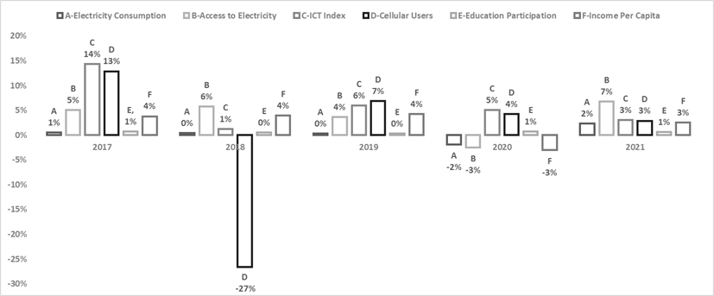
Figure 1. Weacademic
Source: Weacademic, 2010
Tables (Redactional)
Tables should be arranged consecutively (e.g., Table 1, Table 2, etc.). The caption should be center justified and placed above in Cambria 11 pt, bold. The source of data is written under the table in Cambria 9 pt, not italic, as like the following example.
Table 1. The Growth of Islamic Banks and Conventional Banks
Group of Banks | 2013 | 2014 | 2015 | 2016 | 2017
Islamic Banks | 11 | 12 | 12 | 13 | 13
Conventional Banks | 120 | 119 | 118 | 116 | 115
Source: Banking Statistics 2013-2017, processed

